West Hull Ladies
RRC

April
Newsletter

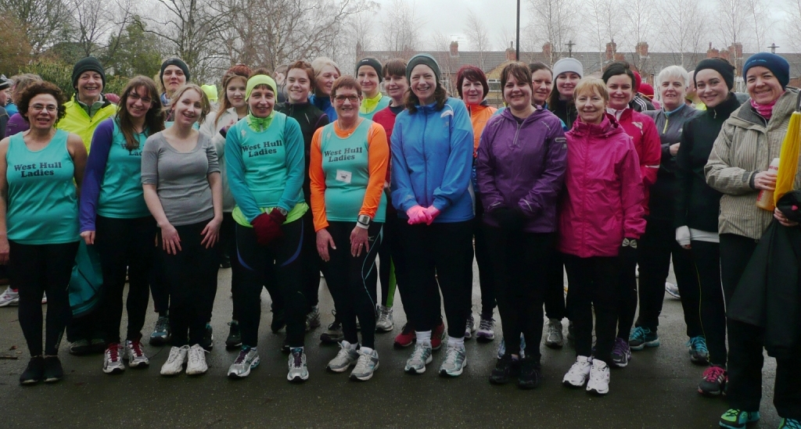

West Hull Ladies
Well Done 6 weeks to 5K Ladies

WEST HULL LADIES RRC
COMMITTEE MEETING

Minutes of Meeting 8th April 2013

Members Present: Jill, Zoe, Debbie, Amanda D, Sandra, Maria, Sally.

- Apologies were received from Verity, Shem, Rachael and Annette
- Minutes of meeting 4th March 2013 accepted as true record
- No matters arising from minutes.
- Discussion about Humber Sports Partnership and Gary Saintys suggestion that we add a group to the Run England Portal and his offer of promoting the work of the Club etc. Agreed that Sandra would follow this up with Gary. ACTION Sandra to contact Gary.
- Sally stated that a few ladies had been on/completed the Safeguarding Children Training and so as a club we had sufficient persons. All agreed that Shem had done excellent work in show casing the Club and beginners’ course at the recent HAN meeting. Jill agreed that via West Hull Ladies email account she would be the email link to HAN. As a group we need to look at areas where we could ask for financial support from HAN – i.e. funding for more training officers. Shem had also suggested alternative venue for the Club to meet, as it may be more cost effective. ACTION – Shem to make enquiries into costs/facilities at alternative premises.
- Fundraising – Rachael had been appointed as Fundraising Officer. All looking forward to hearing what Rachael has in store for us to enable funds to be raised.
- Great British Relay – Amanda updated that there was little response to the email send out to members. It was decided that as 6 had shown interest we would purchase the relay leg from Humber Bridge to St Andrew Quay. Logistics etc to be sorted out nearer the time but it was hoped that many ladies would attend, as it would be good for the Club and for publicity.
- Debbie gave an update as to the Club Finances. Also stated that as it stands we had 32 first Claim paid up members, 1 second claim member and 3 Social members. It is hoped that we will be able to recruit more members.
- Amanda mentioned the 10k series and that although the rules state that the first 10k of the season had to be within 8 % of their last 10k race time some discretion can be made for ladies who had a lengthy time away from running.
- The next meetings were scheduled for 13th May and 3rd June 2013.

Training Officer Tips

Don’t forget your static stretches: It’s really easy to get into the habit of stopping running and going home. Try to spend a few minutes doing some static stretches after your run to help keep you supple. Hold each stretch for at least 10 secs (start counting when you have the stretch in position). It’s not just about reducing injuries, I learnt this weekend it makes for faster races.
Amanda (Training Officer)

Winter Running: We tend to get more injuries during winter, no doubt due to muscles being colder. Pay attention to your warm up and don’t forget to do a series of dynamic stretches (after jogging for 7-8mins: 20 x steps bringing knees up to front, then kicking heels towards buttocks. Side steps swinging arms up – both sides. Skip. Big skips bring knee to elbow.) You look a right wally and it is hard work but gives a good warm up and stretch.
Amanda (Training Officer)

Increase your Weekly Mileage: It’s really easy to get hooked on how well you are doing because you have run further in one go than ever before at one go but your weekly mileage is more important and all our marathon runners can tell you just how true this is. You might feel really pleased that you have run twice in a week doing a 4M and a 7M but running 5M, three times a week is better. The weekly mileage is your foundation and building this up steadily will strengthen joints and muscles without risking injury.
All your Training Officers

Recovery activities such as walking or easy running following intense efforts will speed up the removal of the acid. The first ten minutes of active recovery produces the greatest reduction in lactate and acid levels
Taken from a UKA article

Old trainers tell the truth: If you have a pair of trainers that are wearing out, check the sole. If the wear is in the front part, middle to fore that is perfect. If the heel has wear, you are likely to be over striding which is inefficient and puts you at a high risk of injury due to impact on your joints, work on your running style. If there is wear either side of the sole, you are over or under pronating and may need specific shoes to compensate (note Humber Runner can do an analysis).
Amanda - Training Officer

Static Stretches: When you do your static stretches, concentrate on relaxing the muscle you are stretching. When not thinking, as soon as you feel the stretch, you can tighten the muscle that you are trying to stretch!
Amanda - Training Officer

Runners Tips: Not time to search technical advice so going for my favourite one ... Enjoy! Get down to the club, the company is great and the talking does not stop ... and most ladies keep getting better. J
Amanda - Training Officer

Runners Tips: Active recovery following a long hard run (such as the Rudolph Romp) is considered better than rest . Active recovery simply means doing gentle exercise such as walking which will get blood flowing, help remove lactic acid and accelerate the mending process. See April 2012 newsletter for marathon recovery advice http://www.westhullladies.org.uk/newsletters.htm
Amanda - Training Officer

Runners Tips, Sweet Drinks:
I would not recommend anything artificially sweetened due to a possible negative effect on the nervous system. Sweeteners stimulate hunger by making the body expect an easily available source of energy, which may then prompt a lowering of blood sugar levels and stimulate further hunger. Sweet drinks though useful for fuelling exercise and immediate recovery, should be avoided for general good long term health due to causing erratic fluctuations in blood sugar, which may encourage bad dietary habits, weight gain and cause unnecessary physiological stress.
Mark Mckeown (MSC) Sports Scientist

East Hull 20

Sally

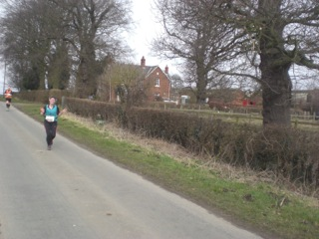
I was really nervous all Saturday, not knowing what to expect & just wanting to finish in 3 or under. It was my longest training run up to that point & I was going to try using Gels for the first time! Sara, Rachael & myself were all a little nervous on the drive to the race, and then we all nearly missed the start, and had to run to the start-line! The race went well & I felt good! The conditions were brilliant & we all managed to finish before it began to rain heavily!! A big thank you to Sandra, Debbie, Jo, LisaD & anyone else who came to support us; it really does make a big difference! Amanda, I know you intended on coming out, but you're forgiven for staying in hospital & having your operation!! Fingers crossed we all feel good and do brilliantly on Marathon day!

Ann

This race was about 4 people – Jamie, Jim, Sandra and my family ...

Pre-Race - Jamie at BodyFixed. He is the man! Having sprained my ankle in February and missing a month of training, and then getting runner’s knee the week before (at least that was his excuse for pulverising my I.T. bands to within an inch of their life), it was always going to be touch and go as to whether this race was going to happen at all. I was a good girl, and did all my exercises (apart from week of pouting and throwing my teddy in the corner), and when Jamie finally gave me the green light to start running, I had, well, 5 weeks to get my training miles up from zero to 26.2 for Blackpool marathon on 7th April. Jamie gave me quite an intensive plan, and with his encouragement and concern, it was game on. The return to running fitness was not easy – if it wasn’t my ankle it was my calf, and once that cleared up then my knee was very painful indeed, even to walk.

I’ve had phantom injuries like these before, so the ‘red hot poker in the knee’ pain I was getting limping around 3 days before was not even reported to Jamie, I just hoped it would go away on the day ...

Race Day – After a sleepless night, I was really excited driving over, and quietly confident. It was good to have my race vest on again and to be meeting up with the others, prior to our dash to the start line (too long in the loo queue). Before I had chance to think, we were off.

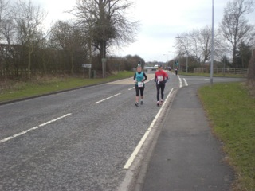
Person number two – Jim – I knew with such inadequate training, I would only succeed by finding company and thus keeping my mind off the task in hand. Enter Jim – an older chap from Baildon (I think), who was training for London – his 12th London marathon. We chatted happily for about 5 miles – but once I started to realise he was going to regale the full details of every single cross country race he ever ran during his national service, I knew it was time to pull away ...

The miles drifted by, I was running slowly, but was feeling comfortable and, more importantly, pain free. Losing Jim meant running alone, and a race like this can be quite isolating at times, so I eventually caught up with another older lady who saw me through the half way point – on the way home, at last! I was feeling strong, and enjoyed overtaking those who had overcooked their first half.
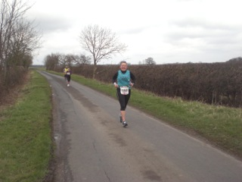
Once I past 13 miles I became more anxious, as this was the furthest I’d run this year ... 14 miles, doing ok – 15 miles ... who’s that? Sandra – what a welcome sight! I’d seen her earlier at the beginning, what a brick, supporting the ladies, but it was wonderful to see her again, and then, get this – she cycled with me the whole way back! Yes, I was hurting, and yes I wanted to have a little walk, but Sandra’s company really, really helped to keep my pecker up, and so the miles drifted by again.

Mile 19 – back to civilisation, but there’s that hill (no, it’s not a big hill, but it looks big on race day). Thanks to Sandra’s encouragement, I was feeling strong still, so powered up the hill, only to come across my family – this was sooo lovely! Anders took over the coach role, and we ran together the last ½ mile to the end. It was wonderful to get waves from the other WHLs, driving past having finished looong before me – thanks for that, ladies!

So it just goes to show – sometimes cross training can help (I kept up my biking and my swimming through my injury), and support from others is simply priceless.

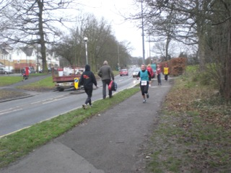

6 weeks to 5k Beginners Course

Amanda Sweeney

I would like to say what a wonderful experience joining the beginners course has given me. So thank you West Hull Ladies and of course my friend Karen S for introducing me to running. I didn’t think for one minute that I could actually run and how quickly I have built my distance up to just over 3 miles non stop running in the 6 wks. If I hadn’t joined the course I think I would have given up at week 2! I believe the lovely encouragement from all the buddies and friendliness of the club has truly encouraged me to run and keep on running and running!
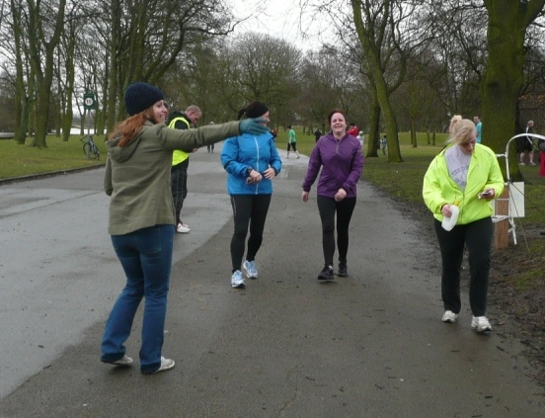
It was lovely to attend the AGM and get a mention – thank you Amanda. Having completed my first achievement of finishing the course and then going onto compete my first 5k at the Park Run was fantastic. I am now aiming for the Jane Tomlinson 10k.

Can I also thank Karen who is going to work with myself and some other ladies from the beginners course until we are running up to a minimum of 5 miles so we are then able to join the main running groups – hopefully within the next 4 weeks.
Look forward to seeing you all soon.

Emma H
Just wanted to say thanks for running the course - it's been really good and I've really enjoyed it!
Thanks
Lindsey
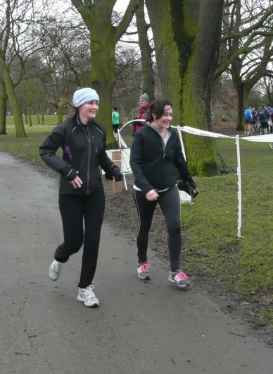
Thanks again for pushing us on really enjoyed the beginners training and the Park Run, it’s a great initiative, am getting into it and enjoying the feeling even though it can be really challenging.
Claire
It really has been such a hugely rewarding process so far; I never believed I could run for 5 minutes, so 5k is a revelation!
I feel much more clear headed, energized& invigorated & the support is really empowering.
So glad I joined!
Thanks a lot
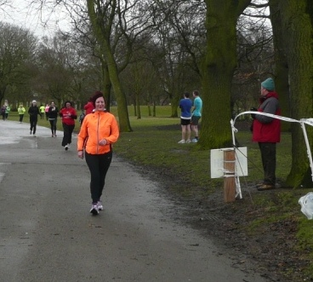
We [Claire and Lindsey] loved Saturday & are all looking run again on Sat 13th April (& get new PB’s!)
Mandy
Can I just say how proud I am to be a West Hull Lady ‘runner’. I am really enjoying the training and the company of all the ladies especially Karen and Amanda S. I am feeling so much better and confident in myself. Thank you
Go girlies ☺
Thank you for inspiring Jacky and myself, we have both really enjoyed running and are both joining the WHL.

Hull parkrun, Saturday 16th March

Click the link, get your barcode and come and run
http://www.parkrun. org.uk/hull/home
A massive turn out from West Hull Ladies for the Hull parkrun. I counted 19 runners (apologies if I missed anyone and please let me know!) and I know there were other ladies marshalling and supporting. Thanks to the buddies, many of whom were running parkrun for the first time themselves. And as for the "beginners" - what a fantastic run you all had! We hope you all enjoyed your experience of parkrun and consider making it a regular feature of your weekend.
Jill: "Just to say well done to all West hull ladies who did the park run. Fab performances from all, but particularly the beginners, you were all awesome! Jill x"
Where to start? Another consistently great time from Debbie and another PB from Zoe, taking 8 seconds off her PB of last week.
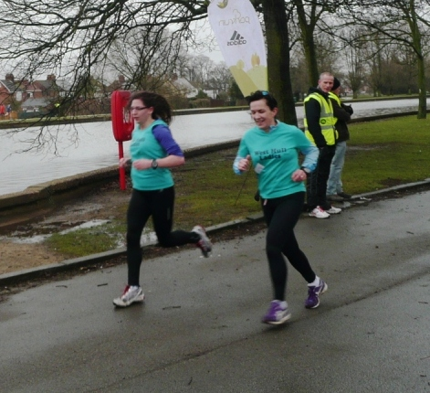

As first timers Jo and Louise both ran superb times. Watch your heels, Debbie!
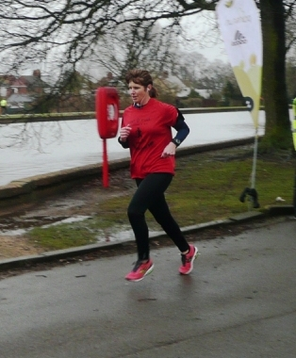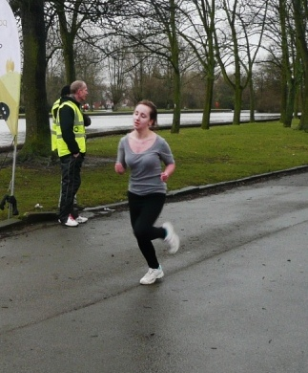

MarieG, are you sure you are a beginner? From no running to a sub-30 minute 5K in 6 weeks is astounding!!! Very well done!
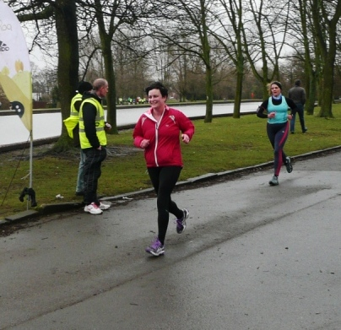

Emma, Mandy, Lindsey, Claire and AmandaS also ran brilliant first times. I haven't met or run with you all yet but I am very impressed.
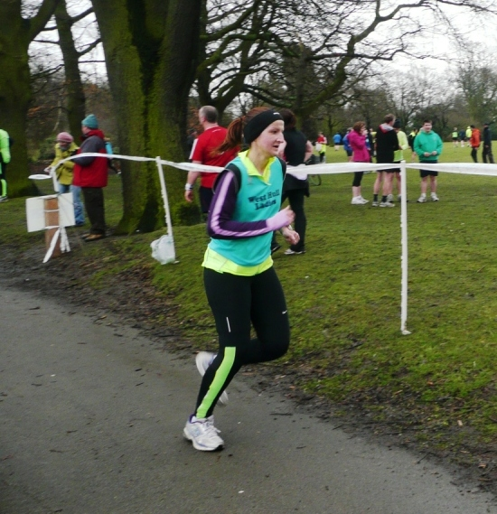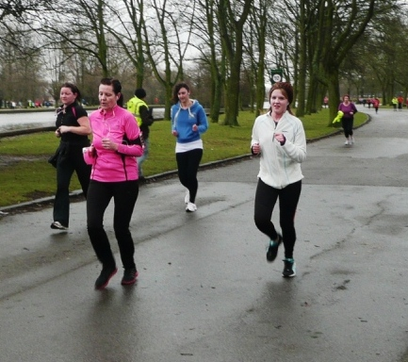

Great to see Kate and Karen back at parkrun and running in support of the Club.
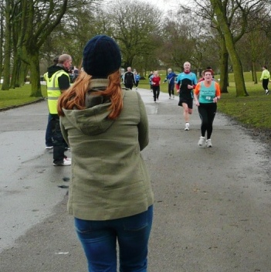

Maria and Sandra, I hope you enjoyed your first parkrun and are proud of your trainees.
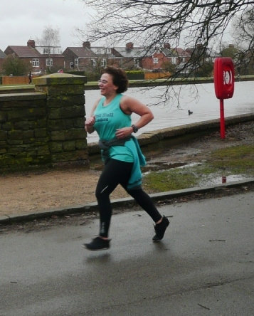

Jill, LisaD, Sarah, Anna and Suzanne, well done as always!
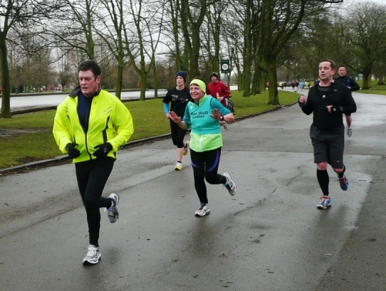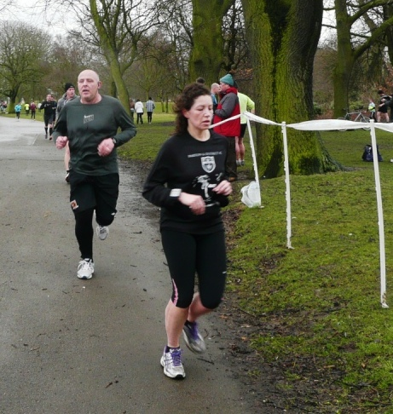
Phew, I think I've done it. Think I'll go for a lie down now and consider the parkrun again myself sometime in the not too distant future.
Great effort all round, ladies: runners, volunteers and supporters!

AGM Prize Winners

Improver of the Year – Jill


Improver Runner Up – Debbie
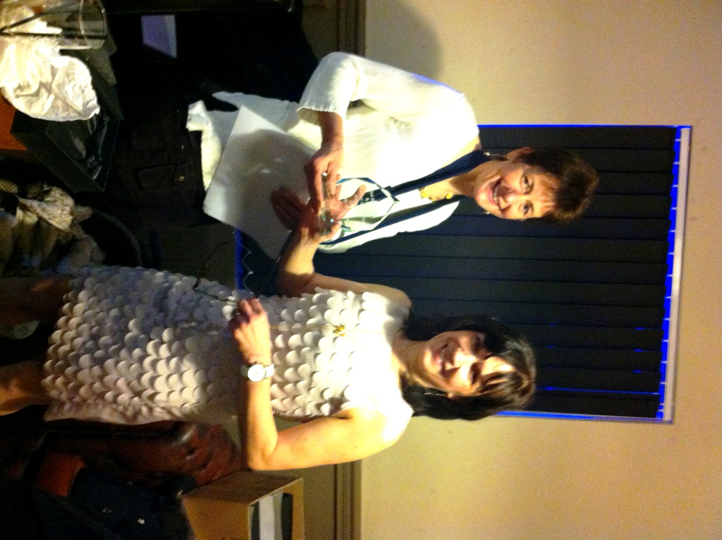

Improver Runner Up – Zoe
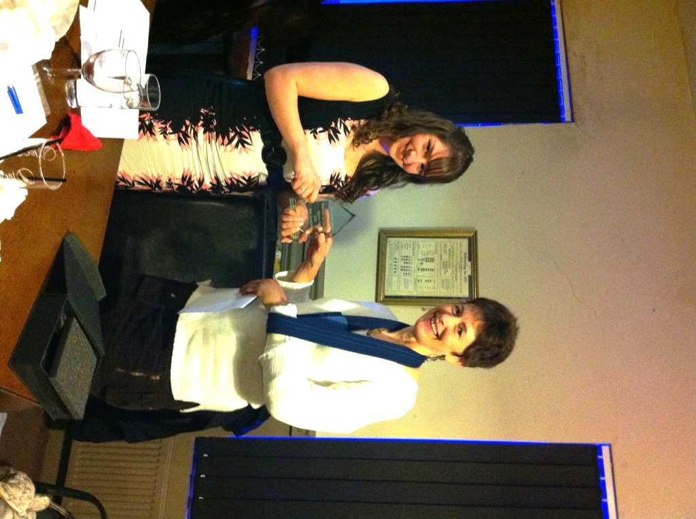

Member of the Year – Amanda

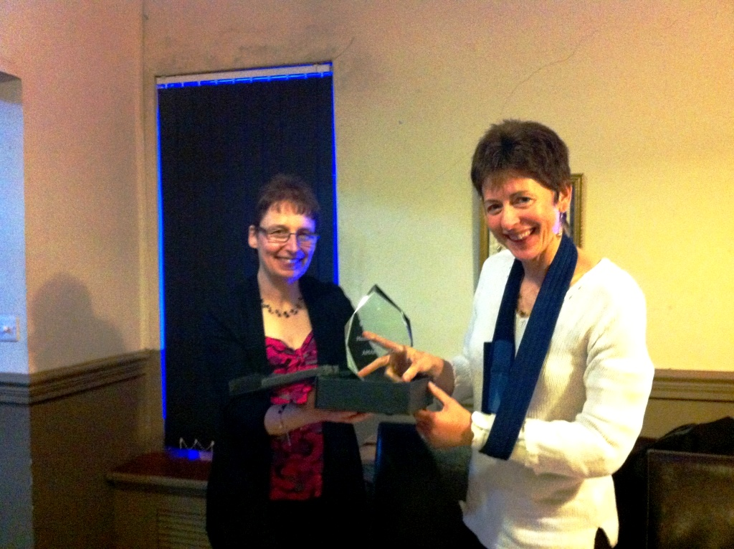

Winner of the 10k series – Rachael, missed out on having her photograph taken.

Racing and Running Events
Fancy something different? For worldwide marathons click here
Date/Time | Event | Fee | Entry forms | Online entry
Apr 2013
13th/08:00 | The Woldsman (50 miles) | £17 | Download form | Enter via email: eyldwa_entries@btinternet.com
28th/09:00 | North Lincolnshire Half Marathon | £24 | Online entry only | Enter at northlincshalf.co.uk
28th/09:00 | Greater Manchester Marathon Marathon | £47.50 +5% booking fee | Online entry only | Enter at greatermanchestermarathon.com
May 2013
4th/08:15-11:30 | Endurance CTS North Yorks Moors Ultra, Marathon, Half Marathon & 10K | £29-£59 | Entry online | Online entry
12th/11:15 | Beverley 10K | £13 | Information (Race full) | Online entry closed
12th/09:30 | Jane Tomlinson's Leeds Half Marathon | £25.20 | Entry form to follow | Online entry
12th/09:00 | Sheffield Half Marathon | £24 | Entry form | Online entry at RunBritain
19th/09:00 | Jane Tomlinson's Hull 10K | £23.20 or click here for season ticket | Entry form to follow | Online entry
26th/11:00 | Driffield Mucky Duck 8.5 miles multi-terrain | £10 UKA/ £12 | Entry form | Online entry
June 2013
2nd/09:30 | Jane Tomlinson's Pennine 10K (Burnley) | £17.20 or click here for season ticket | Entry form to follow | Online entry
9th/11:00 | The Humber Bridge 10K | £11 UKA /£13 | Entry form | Online entry
30th/09:00 | Humber Bridge Half Marathon | £20 | Entry form | Online entry
July 2013
12th/19:30 | Walkington 10K | £11 UKA/£13 | Information - online entry only | Online entry
14th/09:30 | Jane Tomlinson's Leeds 10K | £25.20 or click here for season ticket | Entry form to follow | Online entry
Aug 2013
4th/09:30 | Jane Tomlinson's York 10K | £25.20 or click here for season ticket | Entry form to follow | Online entry
Sept 2013
8th / 10:00 | Major Stone Half Marathon | £15 | Entry form | Online entry(+£1@UKforms.net)

East Hull Harriers Winter League
East Hull Harriers would like to invite WHL club members who would like to run in any of the East Hull Harriers 2012/2013 winter league. You will not feature in the league itself but can take part in the races
There is no entry fee just turn up on the day
Any further information ring John Baker on (01482) 824648.
Thursday 11th April 2013 – Paull Run
Distance: 5.7 miles
Start Time: 7pm
Terrain: Riverbank Footpaths
Venue: Paull Lighthouse
Check EHH website for all up to date information: www.easthullharriers.com


Try a Tri?

Sprint Triathlon - 9th May
Burstwick - Open water swim 750m (see picture), 20k bike, 5k run – Facebook link

Olympic Distance - 13th July
Ripon – have a look at the promo video

Children’s Triathlon – 8th June
Rother Valley - 150 metres swim / 4km cycle / 1.2k run
Check out the website here – this is a whole weekend of triathlon, including a ladies only sprint event

Keep checking the website for new races and updates: www.westhullladies.org.uk/races.htm Verity, Racing Officer

NOTE: Club Vests must be worn at any races you enter
under the West Hull Ladies running club name.

Clubwear
PRICES:
Vest | £16.00 | All items are ordered on request and must be paid for at time of ordering. To place an order please print the kit order form and hand completed forms to Maria.
T- shirt | £16.50
Hoodie | £14.00
Jacket | £32
Beanie Hat | £6.50



New Club Jacket available in three sizes: small, extra small, and junior (large fitting). If you would like to purchase one please send a cheque for £32 to Debbie Watson, Treasurer, and state on the back of your cheque your name and that the cheque is for a jacket.

Jill

Running Library

You can borrow any of these books – they are upstairs near the toilets at the end of the corridor
Book List:
- The Runner's Diet (Runners World), Madelyn H. Fernstrom
- Paula My Story So Far, Paula Radcliffe
- The Runner's Handbook, Bob Glover
- The Competitive Runner's Handbook, Bob Glover & Shelly Lynn Glover
- Marathon Running For Mortals, John Bingham

- Lore of Running,

Running Magazines: These are available to borrow by emailing the club website.
Mark your email for the attention of Jo.

West Hull Ladies Road Running Club
Kit Order Form

FORENAME ___________________________________

SURNAME ___________________________________

ORDER - tick what you require, with size Price

- VEST SIZE _____________ £16.00
- T SHIRT SIZE _____________ £16.50
- JACKET SIZE _____________ £32
- HOODIE SIZE _____________ £14
- BEANIE HAT £6.50

DATE Ordered _______________

AMOUNT PAID _______________

Please make Cheque payable to ‘West Hull Ladies’
Write your name and order on the back.

Sign on receipt of goods _________________________________

DATE _______________

Please print this form, complete and hand to me with your cheque/cash.
Thanks.
Maria
Kit Officer

